THE INDIAN STATISTICAL INSTITUTE, ACT 1959
NO. 57 OF 1959*
(24th December 1959)
An Act to declare the institution known as the Indian Statistical Institute having at present its registered office in Calcutta to be an institution of national importance and to provide for certain matters connected therewith.
BE it enacted by Parliament in the Tenth Year of the Republic of India as follows:
ASI Act 1959
Short title and commencement  Definitions | - This Act may be called the Indian Statistical Institute Act, 1959.  - It shall come into force on such date as the Central Government may, by notification in the Official Gazette, appoint.  - In this Act, unless the context otherwise requires, -  - “Institute” means the Indian Statistical Institute registered under the Societies Registration Act, 1860;  - “ Memorandum” means the memorandum of association of the Institute filed with the Registrar of Joint-Stock Companies under the Societies Registration Act, 1860;  - “ rules and regulations “ includes any rule or regulation (by whatever name called) which the Institute is competent to make in the exercise of the powers conferred on it under the Societies Registration Act, 1860, but shall not include any bye-laws or standing orders under the rules and regulations for the conduct of its day-to-day administration of | 21 of 1860  21 of 1860  21 of 1860
- Published in Extraordinary Issue of the Gazette of India, New Delhi, Part II-Sec. I, No. 46, 26 December 1959 pp.486-490 after debates in Lok Sabha (14 December 1959) and Rajya Sabha (17 December 1959) and after Presidential Assent on 24th December, 1959.
** (amended vide the ISI (Amendment) Act, 1995 ( No.38 of 1995) published in extraordinary Issue of the GOI Part II Section No. 54 dated 5th September, 1995).
- Whereas the objects of the institution known as the Indian Statistical Institute are such as to make it an institution of national importance, it is hereby declared that the Indian Statistical Institute is an institution of national Importance.
**
- Notwithstanding anything contained in the University Grants Commission Act, 1956 or in any other law for the time being in force, the Institute may hold such examinations and grant such degrees and diplomas in statistics, mathematics, quantitative economics, computer science and any such other subject related to statistics as may be determined by the Institute from time to time.
- For the purpose of enabling the Institute to discharge efficiently its functions, including research, education, training, project activities and statistical work relating to planning for national development, the Central Government may, after due appropriation made by Parliament by law on its behalf, pay to the Institute in each financial year such sums of money as that Government considers necessary by way of grant, loan or otherwise.

    - The accounts of the Institute shall be audited by the auditors duly qualified to act as auditors of companies under the Companies Act, 1956, and the Institute shall appoint such auditors as the Central Government may, after consultation with the Comptroller and Auditor General of India and the Institute, select.
    - The Central Government may issue such directions to the auditors in the performance of their duties as it thinks fit.
    - Every such auditors in the performance of his duties shall have at all reasonable times access to the registers, books of accounts, records and other documents of the Institute.
    - The auditors shall submit their report to the Institute and shall also forward a copy thereof to the Central Government for its information
  - Notwithstanding anything contained, in the Societies Registration Act, 1860, or in the memorandum or rules and regulations, the Institute shall not, except with the previous approval of the Central Government
    - alter, extent or abridge any of the purposes for which it has been established or for which it is being used immediately before the commencement of this Act, or amalgamate itself either wholly or partially with any other institution or society; or
    - alter or amend in any manner the memorandum or rules and regulations; or
    - sell or otherwise dispose of any property acquired by the Institute with money specifically provided for such acquisition by the Central Government:
Provided that no such approval shall be necessary in the case of any such movable property or class of movable property as may be specified by the Central Government in this behalf by general or specific order, or
    - be dissolved.
  - The Central Government may constitute as many committees as and when it considers necessary consisting of such number of persons as it thinks fit to appoint thereto and assign to each such Committee all of any of the following duties, namely: -
    - The preparation and submission to the Central Government as far as possible before the commencement of each financial year, of statements, showing programmes of work agreed to be undertaken by the Institute during that year for which the Central Government may provide funds, as well as general financial estimates in respect of such work; and
    - the settlement on broad lines of the programmes of such work
  - Where the Institute does not agree to undertake any work suggested by the Committee referred to in sub-section (I), it shall give to the Central Government its reasons for not so agreeing.
    - The Central Government may constitute a Committee of such number of persons as it thinks fit to appoint them thereto for the purpose of
      - Reviewing the work done by the Institute and the progress made by it;
      - Inspecting its buildings, equipment and other assets;
      - Evaluating the work done by the Institute; and
      - Advising Government generally on any matter, which in the opinion of the Central Government is of importance in connection with the work of the Institute; and the Committees shall submit its reports thereon in such manner as the Central Government may direct.
    - Notice shall be given in every case to the Institute of the intention to cause a review, inspection or evaluation to be made and the Institute shall be entitled to appoint a representative who shall have the right to be present and be heard at such review, inspection or evaluation.
    - The central Government may address the Chairman of the Institute with reference to the result of such review, inspection or evaluation as disclosed in any report of the Committee referred to in Sub-section (1), and the Chairman shall communicate to the Central Government the action, if any, taken thereon.
    - When the Central Government has, in pursuance of sub-section (3), addressed the Chairman of the Institute in connection with any matter, and Chairman does not within a reasonable time take action to the satisfaction of the Central Government in respect thereof, the Central representations made on behalf of the Institute, issue such directions as it considers necessary in respect of any of the matters dealt with in the report.
    - The Institute shall be found to afford all necessary facilities to any Committee constituted under section 8 or section 9 for the purpose of enabling it to carry out its duties.

      - The Central Government may, if it is satisfied that it is necessary so to do in the public interest, issue, for reasons to be recorded and communicated to the Institute, such directions as it thinks fit to the Institute, and such directions may include directions requiring the Institute
        - to amend the memorandum or to make or amend any rule or regulation within such period as may be specified in the directions;
        - to give priorities to the work undertaken or to be undertaken by the Institute in such manner as the Central Government may think fit to specify in this behalf.
      - Any directions issued under this section shall have effect, notwithstanding anything contained in any law for the time being in force or in the memorandum or rules and regulations of the Institute.

      - If, in the opinion of the Central Government: -
        - the Institute without just or reasonable cause had made default in giving effect to any direction issued under sub-section (4) of Section 9 or section 11 ; or
3 of 1956 | 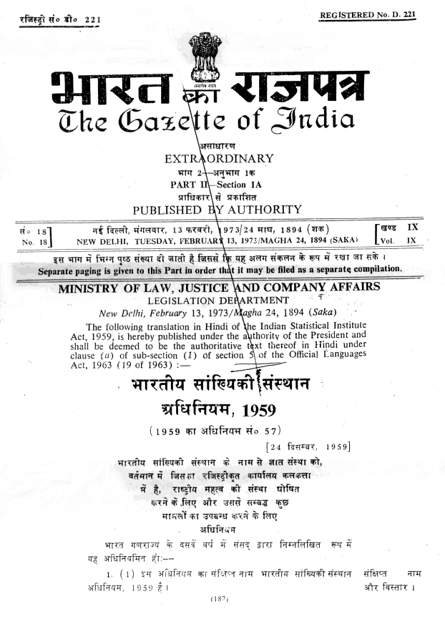
1 of 1956  21 of 1860 | 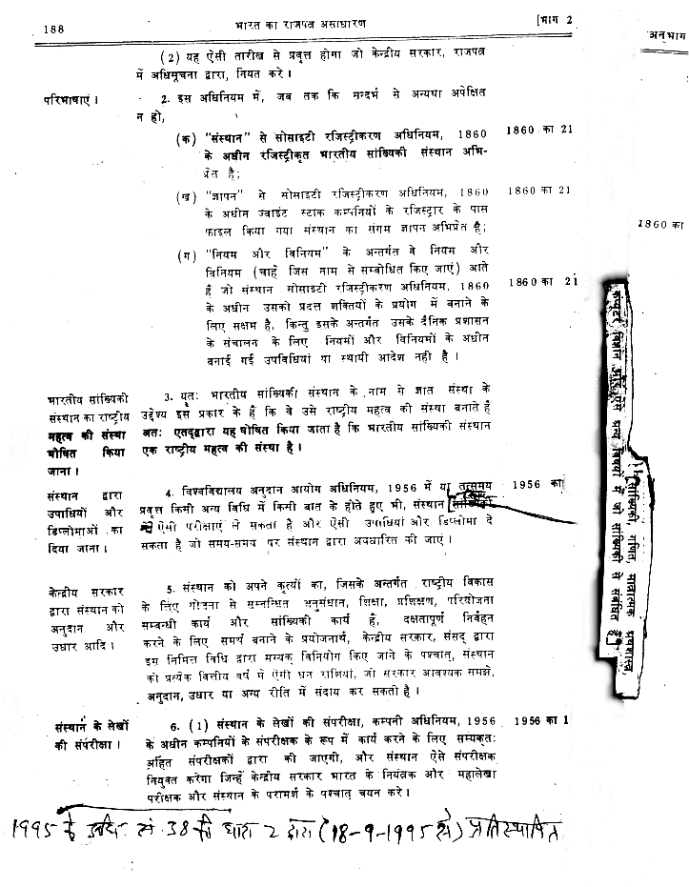
Constitution of Committees by Central Government for preparing programme of work by the Institute | 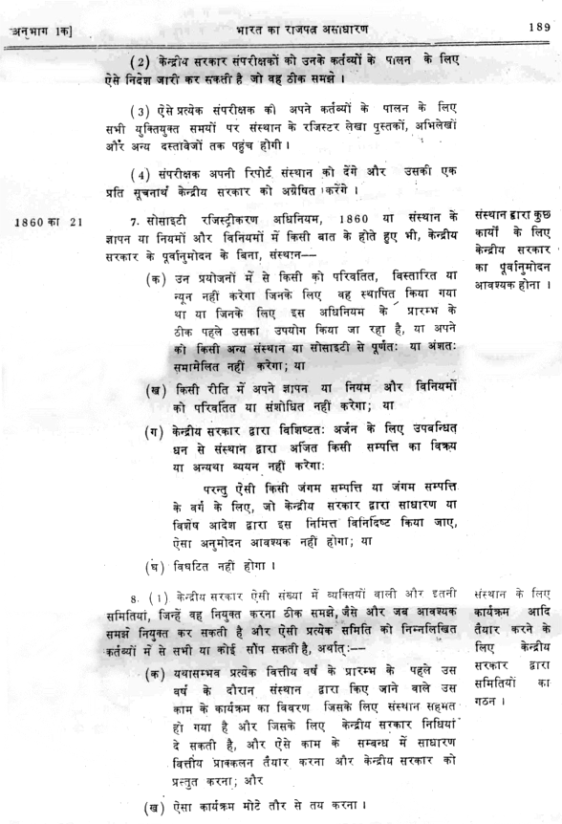
Review of work done, inspection of assets etc. | 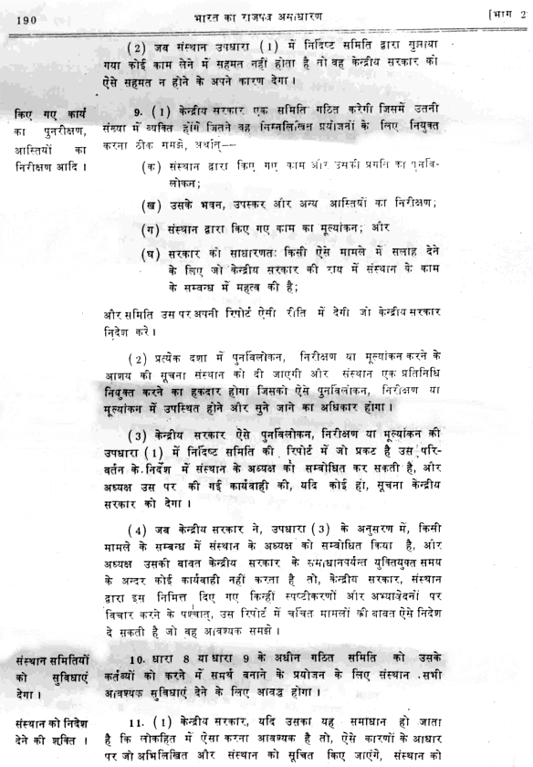
 | 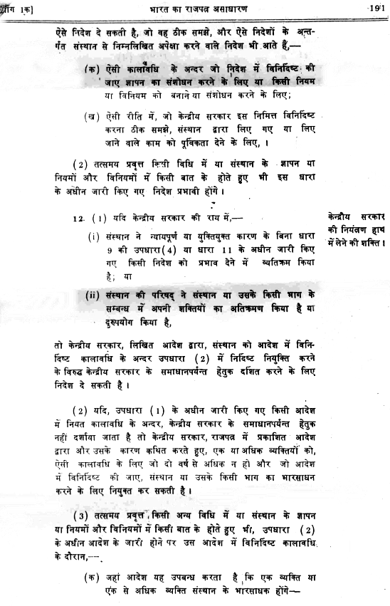
 | 